1. The Earth is exactly 93 Million Miles (150 Million km) away from the sun.

2. a. **The Universe** - is everything which includes all of space, and all the matter and energy that space contains.

b. **Stars** - a luminous ball of gas, mostly hydrogen and helium, held together by its own gravity.

c. **Planets** - a celestial body that orbits around the sun.

d. **Moon** - Earth’s only natural satellite and the fifth largest moon in the solar system

e. **Comet** - are cosmic snowballs of frozen gases, rock, and dust that orbit the Sun. When frozen, they are the size of a small town

f. **Asteroid** - are small, rocky objects that orbit the Sun. They orbit the Sun like planets, but they are much smaller than planets.

3. a. **The Solar System** - is the sun and other celestial bodies held together by gravity. The planets are: Sun, Mercury, Venus, Earth, Mars, Jupiter, Saturn, Uranus, Neptune, Pluto.

b. **Jovian Planets or Gas Giants** are Jupiter, Saturn, Uranus and Neptune.

**Terrestrial Planets** are Mercury, Venus, Earth and Mars.

c. Due to the sun’s gravity pull, the planets in the solar system change from a straight line to a curve, which keeps the planets in orbit around the sun.

4. The earth orbits the sun once every 365 days and rotates its axis once every 24 hours, which causes the day and night cycle to take place.

5. **Lunar Eclipse** - occurs when the earth is precisely between the sun and the moon, and the earth casts its shadow on the lunar surface which turns the moon red.

**Solar Eclipse** - occurs when the moon is directly in front of the sun. The place gets dimmer and dimmer the more the sun is covered by the moon.

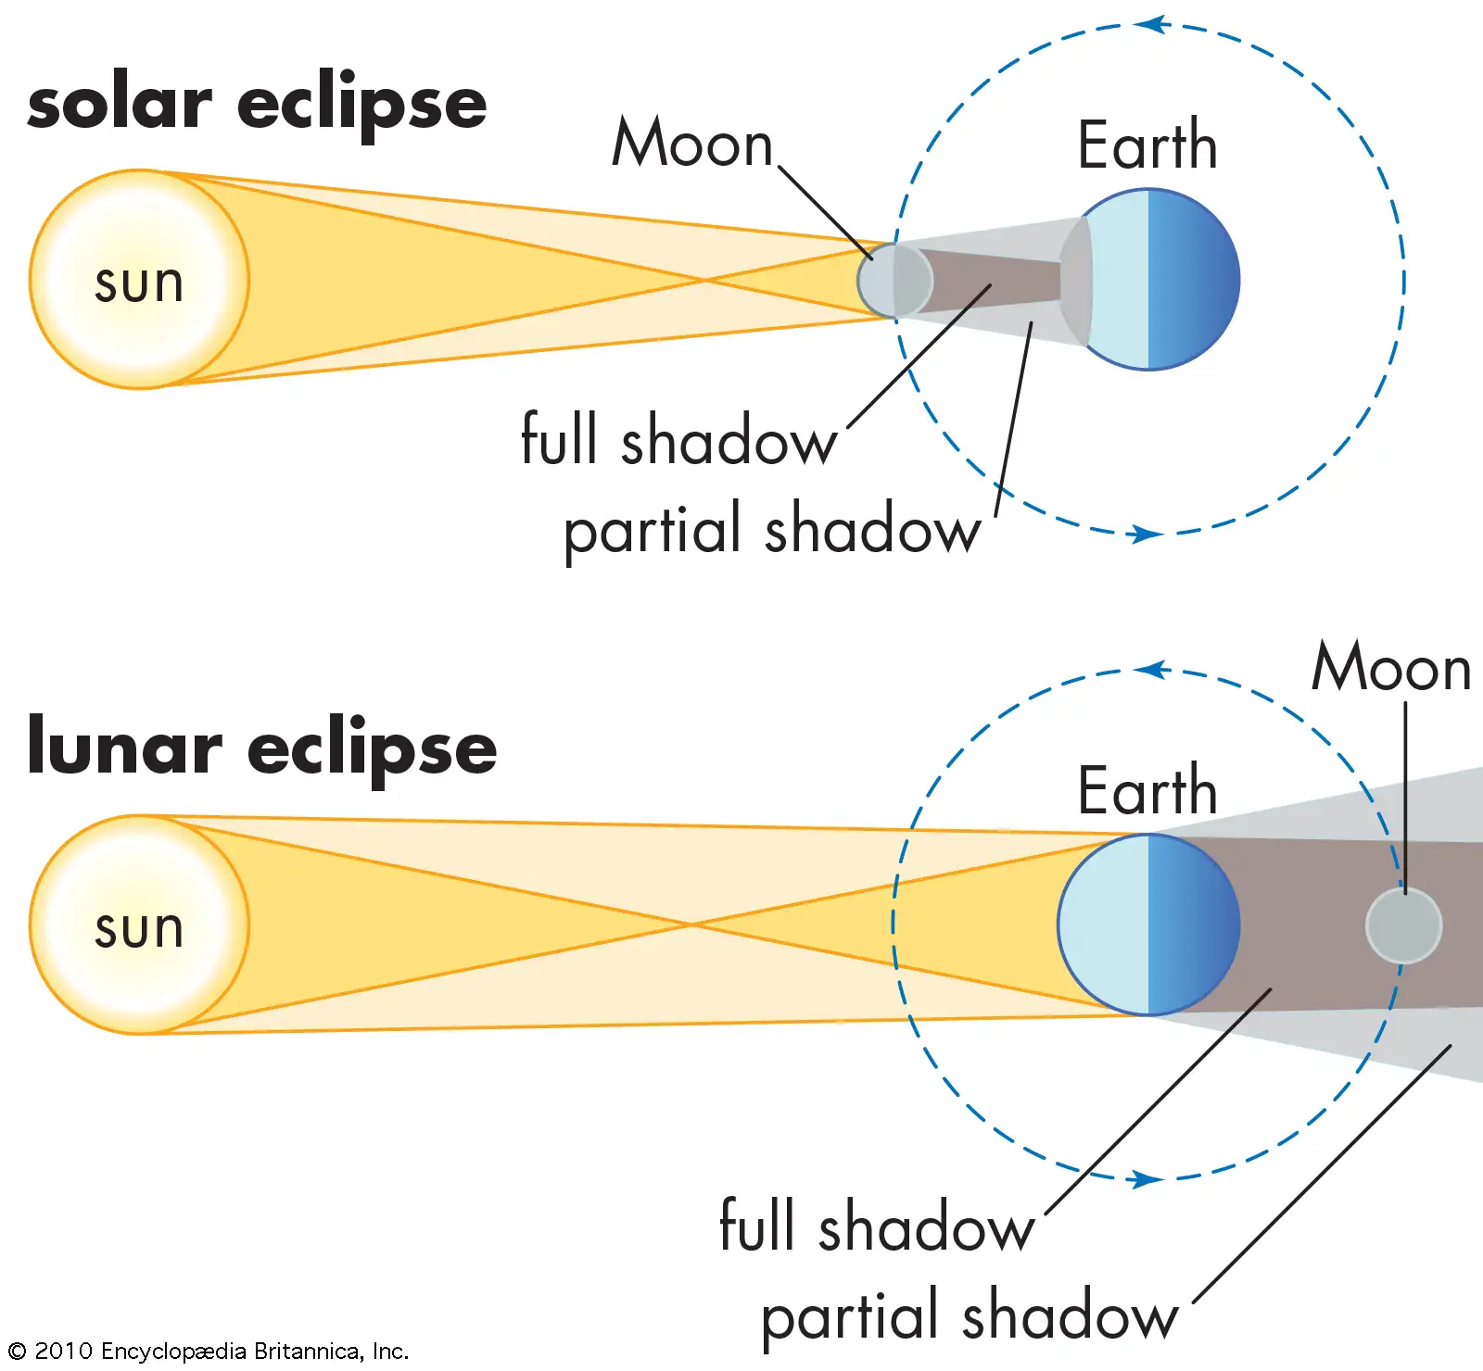

6. **Four reasons to explore the universe are:**

1. Technology and Research.
2. Protection from Asteroids.
3. Improve Health Care
4. Create scientific and technical jobs

7. **Polar Satellite** - revolve around the earth in a northern - southern direction. They are very useful in applications where the field vision of the entire earth is required in a single day.

**Geostationary Satellite** - these satellites are placed into orbit at a distance of around 35,800 km from the earth’s surface. They rotate in the same direction as the earth. They are used as communication satellites.

8. At 02:56 GMT on 21 July 1969, American astronaut Neil Armstrong, together with Edwin 'Buzz' Aldrin and Michael Collin, became the first person to walk on the Moon.

9.

|  |  |  |
| --- | --- | --- |
| **Countries** | **Year** | **Space Stations** |
| USA | May 14, 1973 | Skylab |
| Russia | February 21, 1986 | Mir |
| Joint Project | November 20, 1998 | International Space Station |

10. Pictures used to differentiate between flybys, orbiters, and landers/rovers used in the exploration of mars:

Flybys: Orbiters:

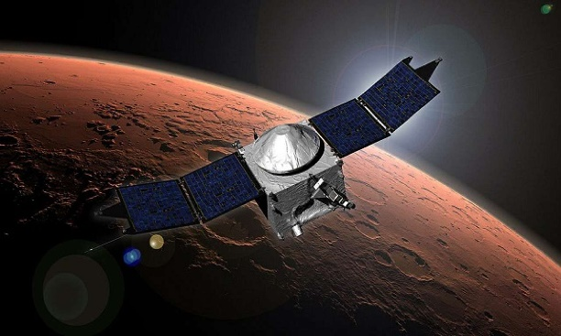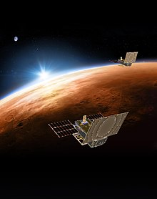

Rovers/Landers:

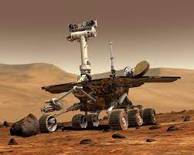

11. A free falling object is an object that is falling under the sole influence of gravity. Any object that is being acted upon only by the force of gravity is said to be in a state of free fall.

Name: Ulric Aird

School: St. Rose Modern Secondary School

Form: 5

Subject: Integrated Science

Topic: The Universe and The Solar System

Teacher: Ms. Pysadee

Date: Friday 9th 2022

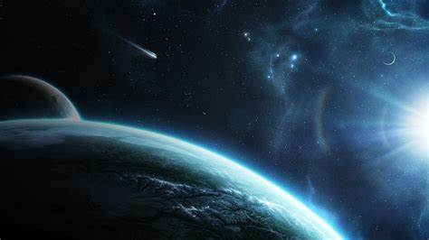

Table Of Content

Exact Location of the Earth…………………………………..Page 1

Describe the different terms related to the solar system….Page 1

Planets………………………………………………………….Page 1

Order of the Planets in the Solar System

List of Jovian Planets and Gas Giants

Why Planets Stay in Orbit around the sun

Why We Experienced Day and Night……………………….Page 1

What happens during lunar and solar eclipse……………..Page 2

Four Reasons for exploring the universe…………………..Page 2

Difference between polar and geostationary satellites……Page 2

First person to go to the moon………………………………Page 3

Space Stations launched by different countries…………..Page 3

Pictures showing flybys, orbiters, and landers/rovers……Page 3

What is Freefall……………………………………………….Page 3